CAcert.org

Branding

and

Style Guide

Version 0.4 – Nov.2007

Introduction

CAcert today stands for Free Certificates and things around it. The focus of our visual identity is our
logo, the unifying element of CAcert.org. We want our corporate logo to represent the value we deliver to
users, association members, core team members, partners, community and the internet at large. This
Branding and Style Guide is intended to help everyone participate in the CAcert community.
The CAcert brand architecture is based on the following principle: We have one corporate logo. This
logo is used to identify all parts of the CAcert project.
This document describes how the CAcert logo should be used on all communication materials such as
stationary, brochures and advertisements.

Basic Elements

- the CAcert Logo

The CAcert.org logo is the unifying visual identifier to be used across all our community and for official
use. Using the logo consistently and correctly is vitally important in reaffirming our brand promise to both
internal and external audiences.
The logo should be the same as presented in this Branding & Style Guide and in the CAcert website.
There are two versions of the basic logo: a colour version, and a monochrome version. The colour
version should be used whenever possible, and must always be placed on a white background. The
monochrome version must be used in situations where the colour version can not be reproduced
correctly, e.g., on cheap printers and fax covers, and on coloured backgrounds. Both versions are equal
in status, but should not mixed together in a single document.

  Logo-Coloured |   Logo-Outlined
The logo should appear in the top right hand corner on all communication materials such as stationary,
brochures and advertisements. Other locations are acceptable if required by the design of the materials.
To ensure its integrity and impact, always maintain a protective clear area around it.
CAcert.org is a community where each User is permitted to and encouraged to create materials for the benefit of the community. Permission is broadly given to registered Users to use the CAcert logo to that end. However, such permission does not imply that you are a legal agent of CAcert.org in contract or similar terms, and you should not represent yourself as an agent. Use of the logo is subject to the normal dispute resolution rules of CAcert.
The CAcert “name” as part of the logo has to be written in latin characters. It is not possible to
adapt it into chinese, arabic, cyrillic or other non-latin characters.
Great care must be taken to protect the logo. To ensure its integrity and impact, always maintain a protective clear area around it.

The logo colours are:
Colour | RGB-values | CMYK-values | HTML-code | Remarks
‘the blue’ | 17, 86, 140 | 93, 66, 31, 13 | #11568C | Pantone© 647C
‘the yellow’ | 255, 255, 0 | 6, 0, 97, 0 | #FFFF00
‘the green’ | 0, 190, 0 | 77, 0, 100, 0 | #00BE00

- Color & Color Usage

Only these colours shown above should be used for Colouring Icons, Graphics, etc. using the Logo itself. Please do not mix them with others like Red, Olive, purple or something else!

Under the Logo (alignment: right) stands the “Subtitle (e.g. Assurer, Partner, Community, Department, etc.).
It was made a difference between Community and official use.

- Official: Subtitle in blue or black
- Community (unofficial): green

If the subtitle was larger then 4-letters then it should be written alignment centred.

Every official document must be verified/allowed by at least one corresponding Officer or One Person of the Core Team.

 | 
e.g. Official Logo | e.g. Community used Logo

- Text Usage

The only important rule is to write CAcert exactly the way it is shown here. Capital ‘C’, capital ‘A’,
lowercase ‘cert’. Not ‘Cacert’. Not ‘CACert’. Not ‘CaCert’ and so on. It’s ‘CAcert’.
If the CAcert company (the .Inc) is mentioned it must always be written as “Cacert.org”. Do not leave out
the “.org” in this situation.
If it fits in the design of the application, a sans-serif typeface like Vera Sans, Arial or Verdana should be
used. CAcert encourages the use of open source typefaces like Vera and Liberation.

The following examples show how the Text and Logo should NOT to be used:


- Logo in angle

- Logo NOT in mentioned colors


- Logo with not authorized Addition, wrong position


- Logo with Picture behind

Logo-misuse 01...04

wrong Textusage:

cacert
CACERT
CaCert
CacerT
CAcert.com

right:

CAcert

or

CAcert.org

explanation:
- First 2 are Capital letters, rest “normal”.

Styleguide for Documents

Stationery

By its very nature, stationery is the most personal and yet formal of all CAcert.org media. It is a key medium for communicating our position as a Community Based CA.
Each time you mail a letter to a partner, hand a business card to a customer or send a memo to a colleague, you have an opportunity to impart the CAcert.org image.
By using the elements of our corporate stationery system correctly and consistently, you help to reinforce the worldwide image of CAcert.org. No matter how innovative we are, we will never replace the personal touch of a hand-signed letter or a handwritten note of thanks.
Stationery is also our primary means of formal correspondence.
Letters, for example, are often legally binding and memoranda are frequently used to document internal agreements.
Together, your efforts and the guidelines will ensure that our stationery is always elegant, always consistent and always visually coherent.
All stationery is printed in solid colors. Exceptions are Online or Screen presentations.

- Letterheads

If necessary use the Logo on a Standard letterhead in the upper right Corner. The CAcert.org Adress or official Contact Address of the Office or Officer should be also as the Root-Certificate Fingerprint implemented at the bottom of the pages.

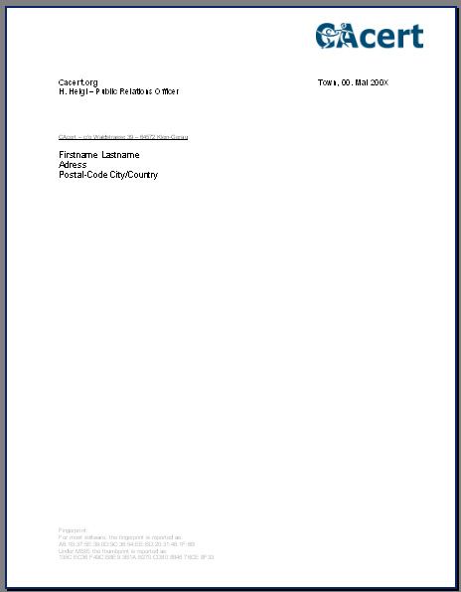

- Memos

Use the Logo in the upper right Corner.

- Badges

Use the Logo in the upper right Corner. The "Function" of the Person should be under his/her name (e.g. Assurer)
Also the CAcert.org root-cert fingerprint should be on the bottom.

Dimensions: 85mm x 52mm

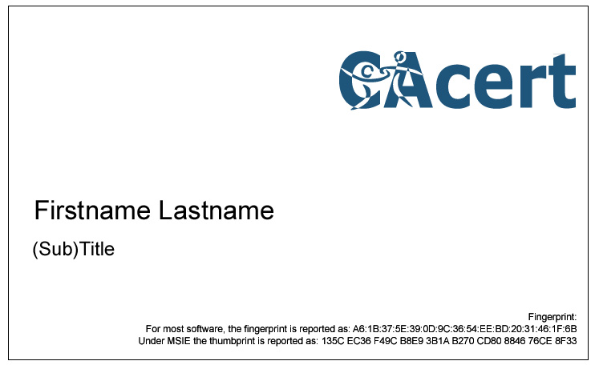
Or some variations:

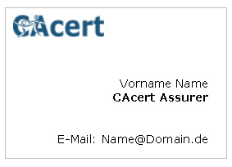

- Presentations

Use the Logo in the upper right or lower right Corner. Try to implement the following necessary informations
- Name of the presentation or for wich event its made
- Date of the event / Presentation
- Name of the Speaker
- The Homepage www.CAcert.org
- The CAcert.org Fingerprint if possible and necessary

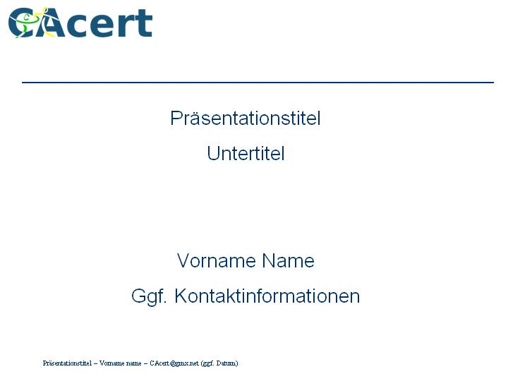

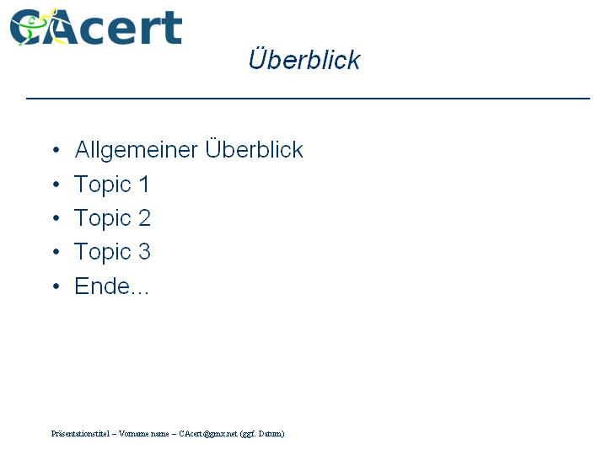

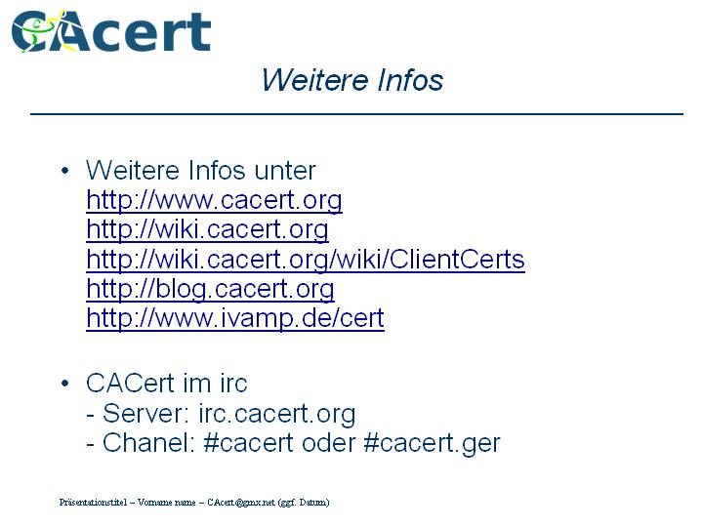

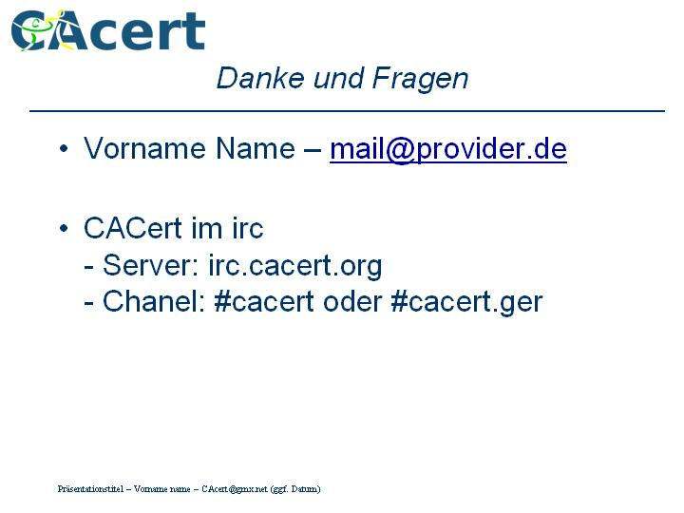

- Brochures

Use the Logo.

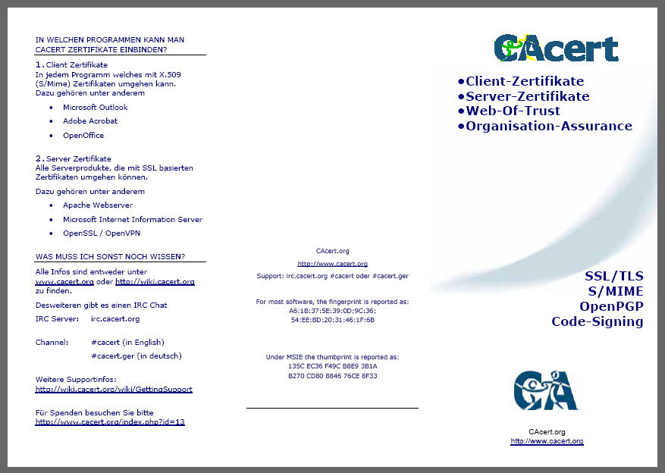
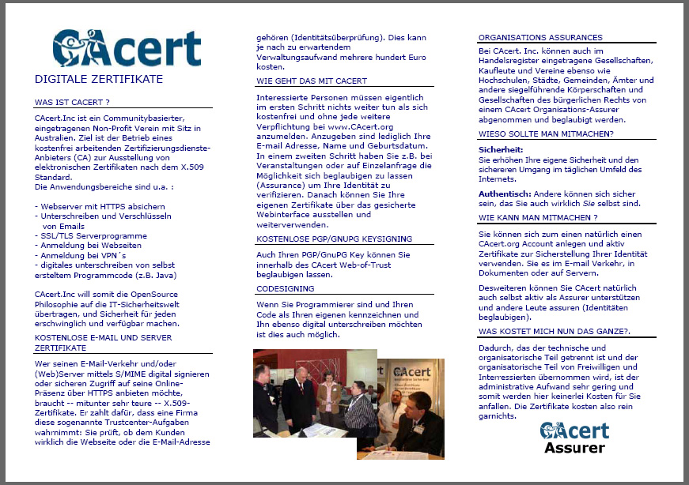

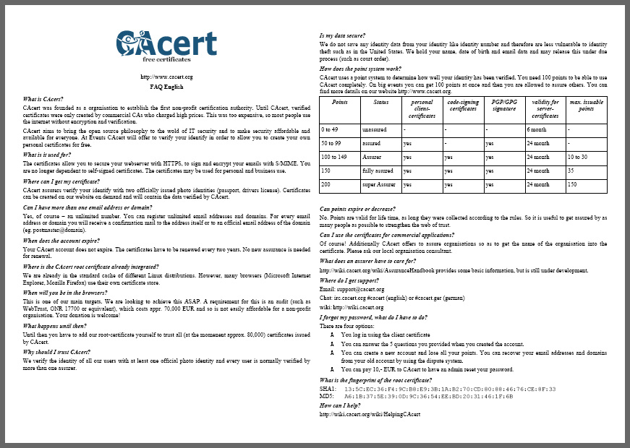

- Recruitment Advertisements, etc.

Use the Logo in the upper right Corner.

- Signage
Signs are a vital part of the CAcert.org identity. They not only serve a practical
purpose – identifying our sites and guiding Users and visitors within them – they are also one of the most visible expressions of the CAcert.org brand. Great care has been taken to develop a
flexible system of signs which expresses the unique personality of CAcert.org in a
unified, consistent way throughout the world.
It is recommend that all official use is signed by the person who write or build the document or other parts made for CAcert.Inc .

Contact information:

If you require further help or advice, have some other information or something wrong or missing please contact your communications representative.

Henrik Heigl – Public Relations Officer CAcert.org
CAcert@gmx.net

